# **NAME: MUHAMMAD MUBASHIR**

# **FATHER NAME: SAEED AKBER**

# **COURSE: MOBILE APPLICATION**

# **COURSE INSTRUCTOR: SALMAN BEDIYA**

**Question:1**

Create a class called "BankAccount" with the following attributes:

account_number (integer)

balance (double)

account_type (string)

interest_rate (double)

And the following methods:

deposit(amount): adds the amount to the balance.

withdraw(amount): subtracts the amount from the balance. You cannot withdraw more than the current balance.

add_interest(): adds interest to the balance based on the interest rate.

display(): prints out the account number, balance, account type, and interest rate.

Then, create two instances of the BankAccount class, each with its own account number, balance, account type, and interest rate.

Finally, call the deposit(), withdraw(), add_interest(), and display() methods on each instance and confirm that the information is updated and displayed correctly.

void main()

{

  BankAccount account1 = BankAccount("Saving",49516,10000,1.9);

  BankAccount account2 = BankAccount("Saving",30293,50000,4.9);

  print("First account information");

  account1.deposit(7000);

  account1.withdraw(2500);

  account1.addInterest();

  account1.display();

  print("Second account information");

  account2.deposit(9000);

  account2.withdraw(3500);

  account2.addInterest();

  account2.display();

}

class BankAccount{

  String accountType;

  int accountNumber;

  double balance;

  double interestRate;

BankAccount(this.accountType,this.accountNumber,this.balance,this.interestRate);

void deposit(double amount)

{

  balance = balance + amount;

  print(balance);

}

void withdraw(double amount)

{

  if(amount <= balance){

  balance = balance - amount;

  print(balance);

  }

  else{

    print("You cannot withdraw more than the current balance.");

  }

}

void addInterest()

{

  double interest = ( balance * (interestRate/100));

  balance = balance + interest;

  print(balance);

}

void display(){

  print("My Account type is $accountType");

  print("Account  Number is $accountNumber");

  print("Balance is $balance");

  print("My interest Rate is is $interestRate");

}

}

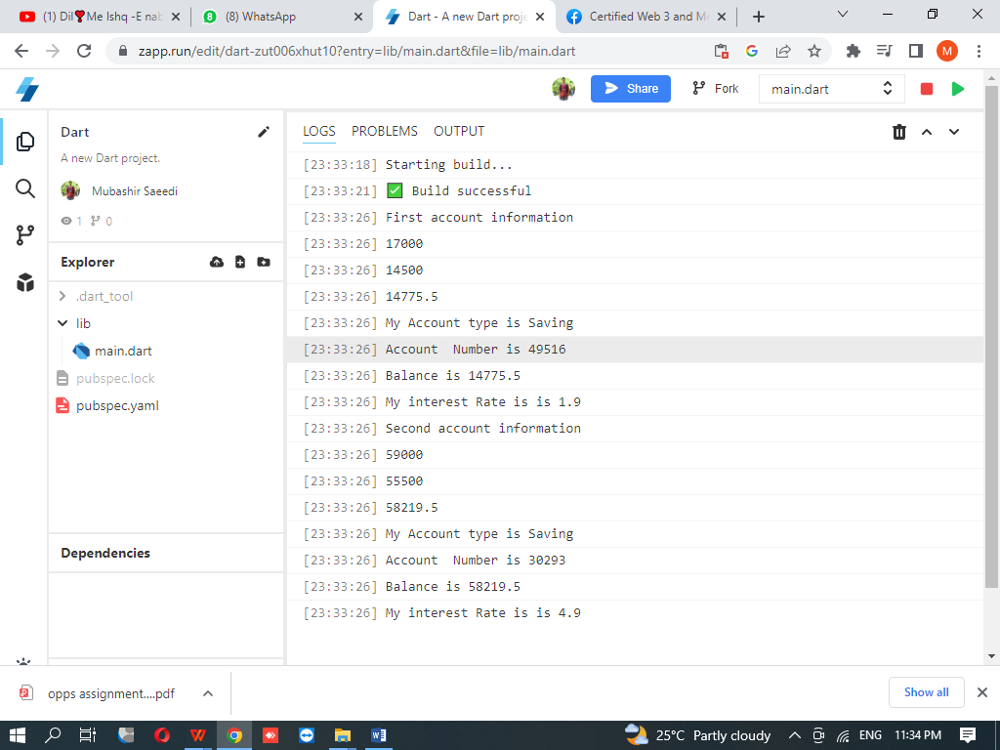

**Question:2**

Create a class called "Student" with the following attributes:

name (string)

id (string)

courses (list of strings)

And the following methods:

add_course(course): adds a course to the student's list of courses.

drop_course(course): removes a course from the student's list of courses.

display_courses(): prints out the student's list of courses.

Then, create two instances of the Student class, each with their name, id, and courses.

Finally, call the add_course(), drop_course(), and display_courses() methods on each instance and confirm that the information is updated and displayed correctly.

void main(List<String> args)

{

 print("First Student Information");

 Student stud1 = Student("Asad","201A-F22-005",["computer,Urdu"]);

 stud1.add_course("Physics");

 stud1.drop_course("Chemistry");

 stud1.display_courses();

 print("Second Student Information");

 Student stud2 = Student("Bawany","BSE-22S-082",["English,Urdu"]);

 stud2.add_course("ICT");

 stud2.drop_course("DSA");

 stud2.display_courses();

}

class Student

{

 String name;

 String id;

 List <String> courses;

 Student(this.name,this.id,this.courses);

 void add_course(String course)

 {

  courses.add(course);

 }

 void drop_course(String course)

 {

  courses.remove(course);

 }

 void display_courses()

 {

  print('${name}\'s courses: ${courses.join(",")}');

 }

 }

